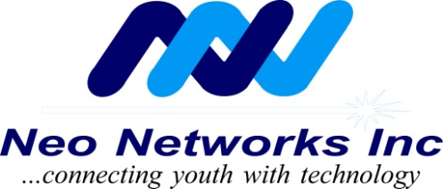

December, 2010
Volume 1, Issue 4

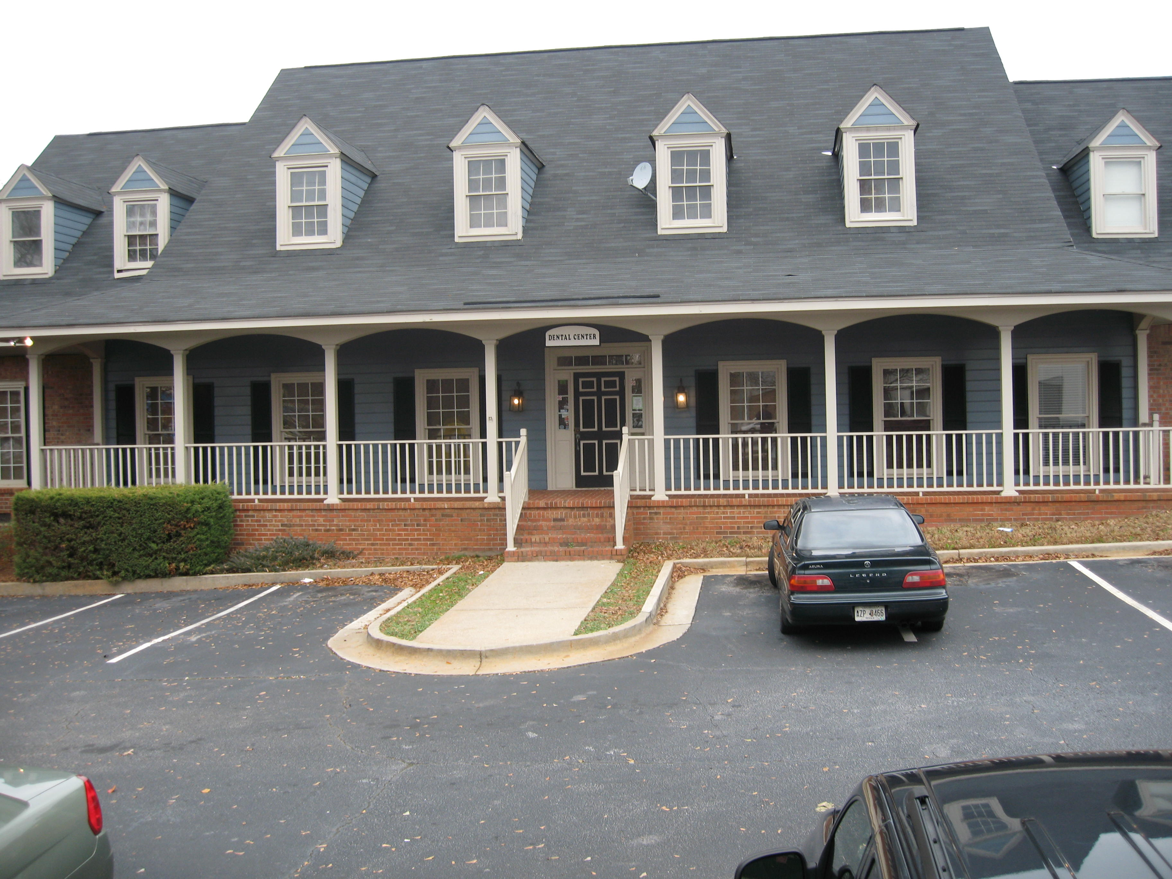

Inside This Issue

- The President’s Speaks..

- Clarkston Community Center Added Neo Networks to it List

- Accomplishments

- Neo Networks Future Plans.

- Special Thanks

- How to Contribute

- The Wish List

Neo Networks, Inc
1147 S. Hairston Rd, Ste D
Stone Mountain, GA 30088
Ph. 404-297-4678
www.neonetworks@comcast.net

A Not For Profit Organization

The President
THE NETWORK
CONNECTION
Speaks…
Transparency and Change…
.

Neo Networks would like to extend a big thank you to all of our supporters, contributors and volunteers. Neo Networks is faced every day with challenges and without your support, Neo Networks would not be able to continue to work toward accomplishing all of our goals.

Jason Frederick, President/CEO

Accomplishments:

It has been over four years since I began my dream of having Neo Networks mentoring and teaching technology skills to youth and adults of all ages and nationalities. To date, I am very proud of our accomplishments and I look forward to establishing relationships with additional organizations, as well as extending our efforts to other neighboring cities.

Here is a list or Neo Networks recent accomplishments:

- Our partnership with Clarkston Community Center, (CCC). Enabled the Center to gained a converted Neighborhood Excellence Community Service award from Bank of America and an Educational Seminar. Jason – CEO was given the opportunity to participate in the travelling Seminar. The Seminar served to expand his network of communication with others in various Community Services from all over the United States. The first of the three locations was in California.

Jason was accepted to Georgia State University Graduate Program. He is pursuing his Masters in Mathematics.

Jason is committed to helping youth. In December 2009 he gave up his Computer Programming Job and accepted a full time teaching position. Presently he is teaching eleventh grade math in Fulton County Public School.

1) Neo Networks continues to teach computer literacy at Clarkston Community Center and at another senior center in DeKalb County.
2) Neo Networks participates in two after school programs
(a) Kindergarten to fifth grade in DeKalb County.
(b) Fifth grade to ninth grade in DeKalb County.
At both locations Neo Networks help the kids with the following:
- Homework assignments and special projects.
- Provides healthy snacks for all the children.
- Provides school supplies, on an as needed basis.
- Opal Frederick, a registered Nurse continues to teach them the importance of eating healthy foods and hand washing.
3) Neo Networks donated six soccer balls to local youth soccer team whose players are part of the after school program.
4) Earle served as assistant soccer team coach and Opal served as soccer mom.
5) Partnership with Clarkston Health Collaborative Bike Rodeo on September 11, 2010.
Results:
A. 51 kids registered
B. Bike repairs were made
C. Helmet fittings were done
D Dekalb Bar Association (Trial lawyers) Bill Moon, Earle Frederick (Neo Networks) N. Atlanta Urgent Care, and Bike South were great partners/partners.
Plenty of giveaways were distributed.

6) As member of the Atlanta Down Town Neighborhood Association, Earle participates in the monthly Community clean-up.

7) During the Christmas holidays, Neo Networks participated in feeding the homeless at a local church in Atlanta.

8.) Neo Networks participated in the Clarkston Business Association Celebration by providing DJ music as entertainment for the local community. DJ music was also provided at special events at two other senior centers (Birthday Parties and at luncheons). This is very up lifting for these seniors.
for updated Computers received from the Center of Disease Control

9) Participated in the Clarkston Health Collaborative end of year celebration. During this time there were people from different nationalities sharing their foods.
This was a wonderfull time of fellowship where we got to meet and greet one another including local officials from DeKalb County.

10) Earle repaired and redistributed refurbished computers to needy seniors

11) Neo Network provided scholarships to students attending graduate and under graduate programs in the Atlanta area.

12) Participate in a “round table” Community Café discussion at Clarkston Community Center in December, sponsored by United Way.

Neo Network Interview

Ernest Holsendolph (Neo Networks Inc.) interviews John O’Kelly (Former Executive Director of Clarkston)

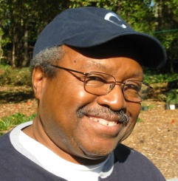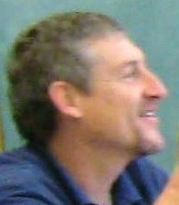
Ernest John
Neo Networks Inc. and Clarkston Community Center are natural partners. Neo Networks, which was born to help, fits just fine with Clarkston, a diverse but very needy community.

“We’re like a little Ellis Island,” said John O’Kelly, who has been executive director of the center for approximately six years. His reference was to the fact that the Clarkston community has been the landing spot for refugees and others, much like the historic immigration center in New York.

“A study showed that 52 languages were spoken at Clarkston High School, “he said, with residents ranging from the Vietnamese in the Far East to Bosnians in southeastern Europe, to the huge Somali population from Horn of Africa.

And the people who come to the center are in need of much, from language preparation, to job and social skills, to recreation and education---especially among the senior citizens.

“ When Jason Frederick came to me and said his organization could offer tutoring and computer training, we were delighted!” he said.

The kinds of service and outreach fit in well with the community center mission to provide help in the areas of arts, recreation, health, educational and community development.

“What really amazed me, “he said, “was that Jason came so well organized, and with his own 501(c) 3 tax exempt. That is an amazing accomplishment at just 29 years old”. The 501 (c) 3 is a formal status conferred by the Internal Revenue Service that allows the organization to receive donations with a tax exempt privilege.

The work with Neo Networks is an award winner, gaining a coveted Neighborhood Excellence community service award from Bank of America, and an educational seminar for Jason. The traveling seminar serves to expand Jason’s knowledge, and expand his network of communication with others in various community services.

“You will be amazed to sit in my office and listen to the parade of people who come in and say they would love to help kids, but they have no particular training or orientation,” said O’Kelly. “Connecting with Jason and Neo Networks has been a blessing to us.”

O’Kelly understands the needs of the new immigrant population, especially from Africa. He was a linguist missionary to Niger before he headed Clarkston Community Center. “I learned to love and respect the languages, the culture and the people,” he said.

In addition to the Neo Networks services, clients of all ages come to the center for activities as varied as soccer play, job training, sewing and beading, playwriting, drama productions, Taichung and bluegrass music.

The Fugues, now a nationally known soccer team with refugees as players, got its initial start on the soccer fields of Clarkston.

Like many self-help community organization, Clarkston is worried about the future of its support base. Bank of America has been a main source of financial support, he said, but we all know the troubles banks face in the recession.

“On our present course, we are not financially self-sustainable,” he said, which is one of the reasons why the center deeply appreciates the work of volunteers like Neo Networks .

By: Ernest Holsendolph

Earle Frederick and Opal Frederick received certificates of appreciation for their volunteer work in the communities.

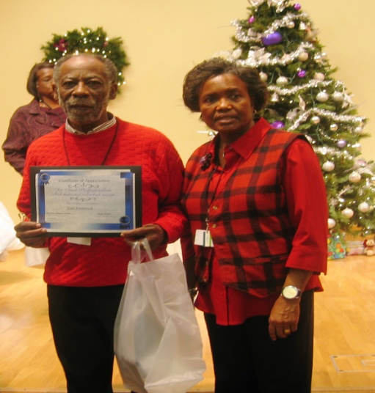
Earle and Opal

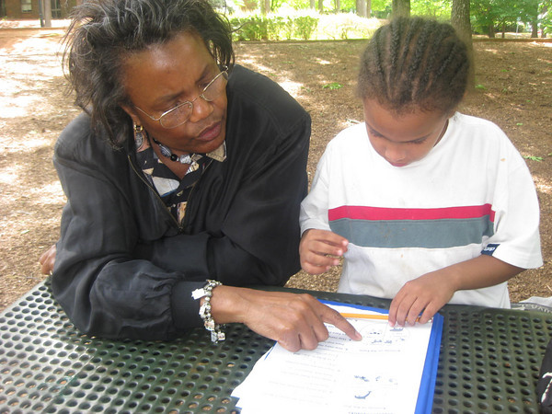
.
Opal tutors in reading, health
issues and provides healthy
snacks

Neo Networks
Future Plans . . .

At Job Corps:

Continue the outstanding work in Math at the Job Corps Center.

At Clarkston Community Center
(CCC): Continue our computer literacy classes

Continue to teach computer literacy at other community Centers.

Continue our after school programs and expand in to others if possible.

Assist with youth soccer programs.

Neo Networks

SPECIAL THANKS TO..…..

Neo Network received special thanks from McKenzie Wren the Director of Clarkston Community Center for updating the computer lab. The computer lab was completely rewired and networked

Earle donated the Computers removed from the Lab to his students in the Wednesday class at the CCC.

To all our volunteers, friends and dedicated doners.Thank you for making the year 2010 a great success.

Special thanks to all of our Board Members – Ernest Holsendolph, Justin Wingo, Stephannie Anderson and Jim Williams for their hard work
Counselors:
Shaka Hines and Loressa Sutton

Clarkston Community Center

Mr. John H. O’Kelley (past Executive Director)

Mckenzie Wren (present Executive Director)

Charlene Bowens, MSW Career Counselor at Job Corp.

HOW TO

CONTRIBUTE

Neo Networks can always use help in various areas. If you would like to volunteer, donate, or
make a monthly pledge, please send an email to neonetworks@comcast.net with your contact information and area in which you are able to help.

THE WISH LIST

1. Pentium 4 Computers (Used or
Non Working)

2. Educational Programs and
Books

3. School supplies-Pencils and
Paper

3. Labtops

4. Electronic Project Kits for
students between the ages of
12- 15

