

February 2007
Volume 1, Issue 1

Inside This Issue

- The President’s Dream

- About Neo Networks, Inc

- First Year

Accomplishments

- At The Future

Foundation/Reef House

- Field Trips

- At Job Corps Center

- To The Seniors

- Message From The

President

- Special Thanks

- How to Contribute

- The Wish List

Neo Networks, Inc
1147 S. Hairston Rd, Ste D
Stone Mountain, GA 30088
Ph. 404-297-4678
www.neonetworks@comcast.net

A Not For Profit Organization



The President’s
THE NETWORK
CONNECTION
Dream . . .

At a time when most young people his age are content putting their college degree to work via their first job out of college, Jason Frederick of Stone Mountain has launched an ambitious youth enrichment and computer literacy program to strengthen the community. Frederick, a graduate of Woodward Academy and Morehouse College, is the president of Neo Networks Inc, a nonprofit agency that he has created to help youngsters and others understand digital technology and aspire to go to college. "I have been very fortunate to get a good education, at Woodward and Morehouse, and I just want to help others realize their potential, while giving back to the community," Frederick said.
Neo Networks, his instrument for community help, is an effort to augment the work of public schools by trying to stimulate youngsters to become ambitious and aware of technical job opportunities and careers. In the statement of purpose, Neo Networks proclaims that its organization is "designed to educate the mind, foster the development of the whole child, nurture the spirit, and educate youths in the area of computer literacy." Moreover, the project tries to raise goals, "stimulating the desire for life-long learning, intellectual curiosity, and promoting individual self esteem.”
The Neo Networks team sets about its task by conducting classes in computing and tutoring youngsters in subjects such as math and typing, as well as counseling them on ways to plan for college and professions.
Much of the work is being done with youngsters in Job Corps programs, in the homes of senior citizens, and in an after school program in College Park operated by Shareef Abdur-Rahim, an NBA basketball player active in the South Atlanta community.
Even as a student, Jason began to conceive of Neo Networks, named after a central character in The Matrix. Neo, in the Matrix movies, gradually discovers remarkable powers within himself, much as the visionary student may do, given the proper guidance.
Frederick started the process of forming a nonprofit agency in 2005 and last year started the organization with the assistance of friends, acquaintances, and his parents. An athlete who played soccer in school, Frederick has called upon his high levels of energy to balance a full-time and part-time job and spends all his free time with students and other clients of the program.
By: Ernest Holsendolph

About . . . .

Neo Networks, Incorporated
A board of directors guides Neo Networks, which is organized as a nonprofit tax-exempt agency with top officers including Jason Frederick as chief executive officer and president. Other officers include Justin Wingo, vice president, and Stephanie Anderson, Secretary.
Other board members include Jim Williams, Ernest Holsendolph, and Gwatoh Kroma.
Other leaders include Earle Frederick, program director; Opal Frederick, resource coordinator; Henrietta Johnson, administrative assistant; Laryssa Sutton, mentor; Shaka Hinds, mentor, and Varley Simons, editor.

First Year Accomplishments

- Launched status as an organization under 501 (C) (3) of the Internal Revenue Service Code effective January 2006.
- Informed by the IRS that Neo Networks qualifies July 27, 2006.
- Mentors and teaches technology skills to students at The Future Foundation/Reef House.
- Tutors young people in math at Job Corps.
- Sharpens the computer skills at a senior citizen center.
At The Future Foundation / Reef House

On September 13, 2006, a formal class in health and nutrition was launched, on Wednesdays for a month. The class was directed by Opal Frederick, a professional nurse. Youngsters were taught the types of foods, including the five major food groups and the new food pyramid.
At the completion of the course, youngsters who previously were unaware of the role of foods, could name at least three examples from each of the food groups. They could also read food group labels, count calories and recite the cholesterol content of foods, as well as fats and sugars.
. 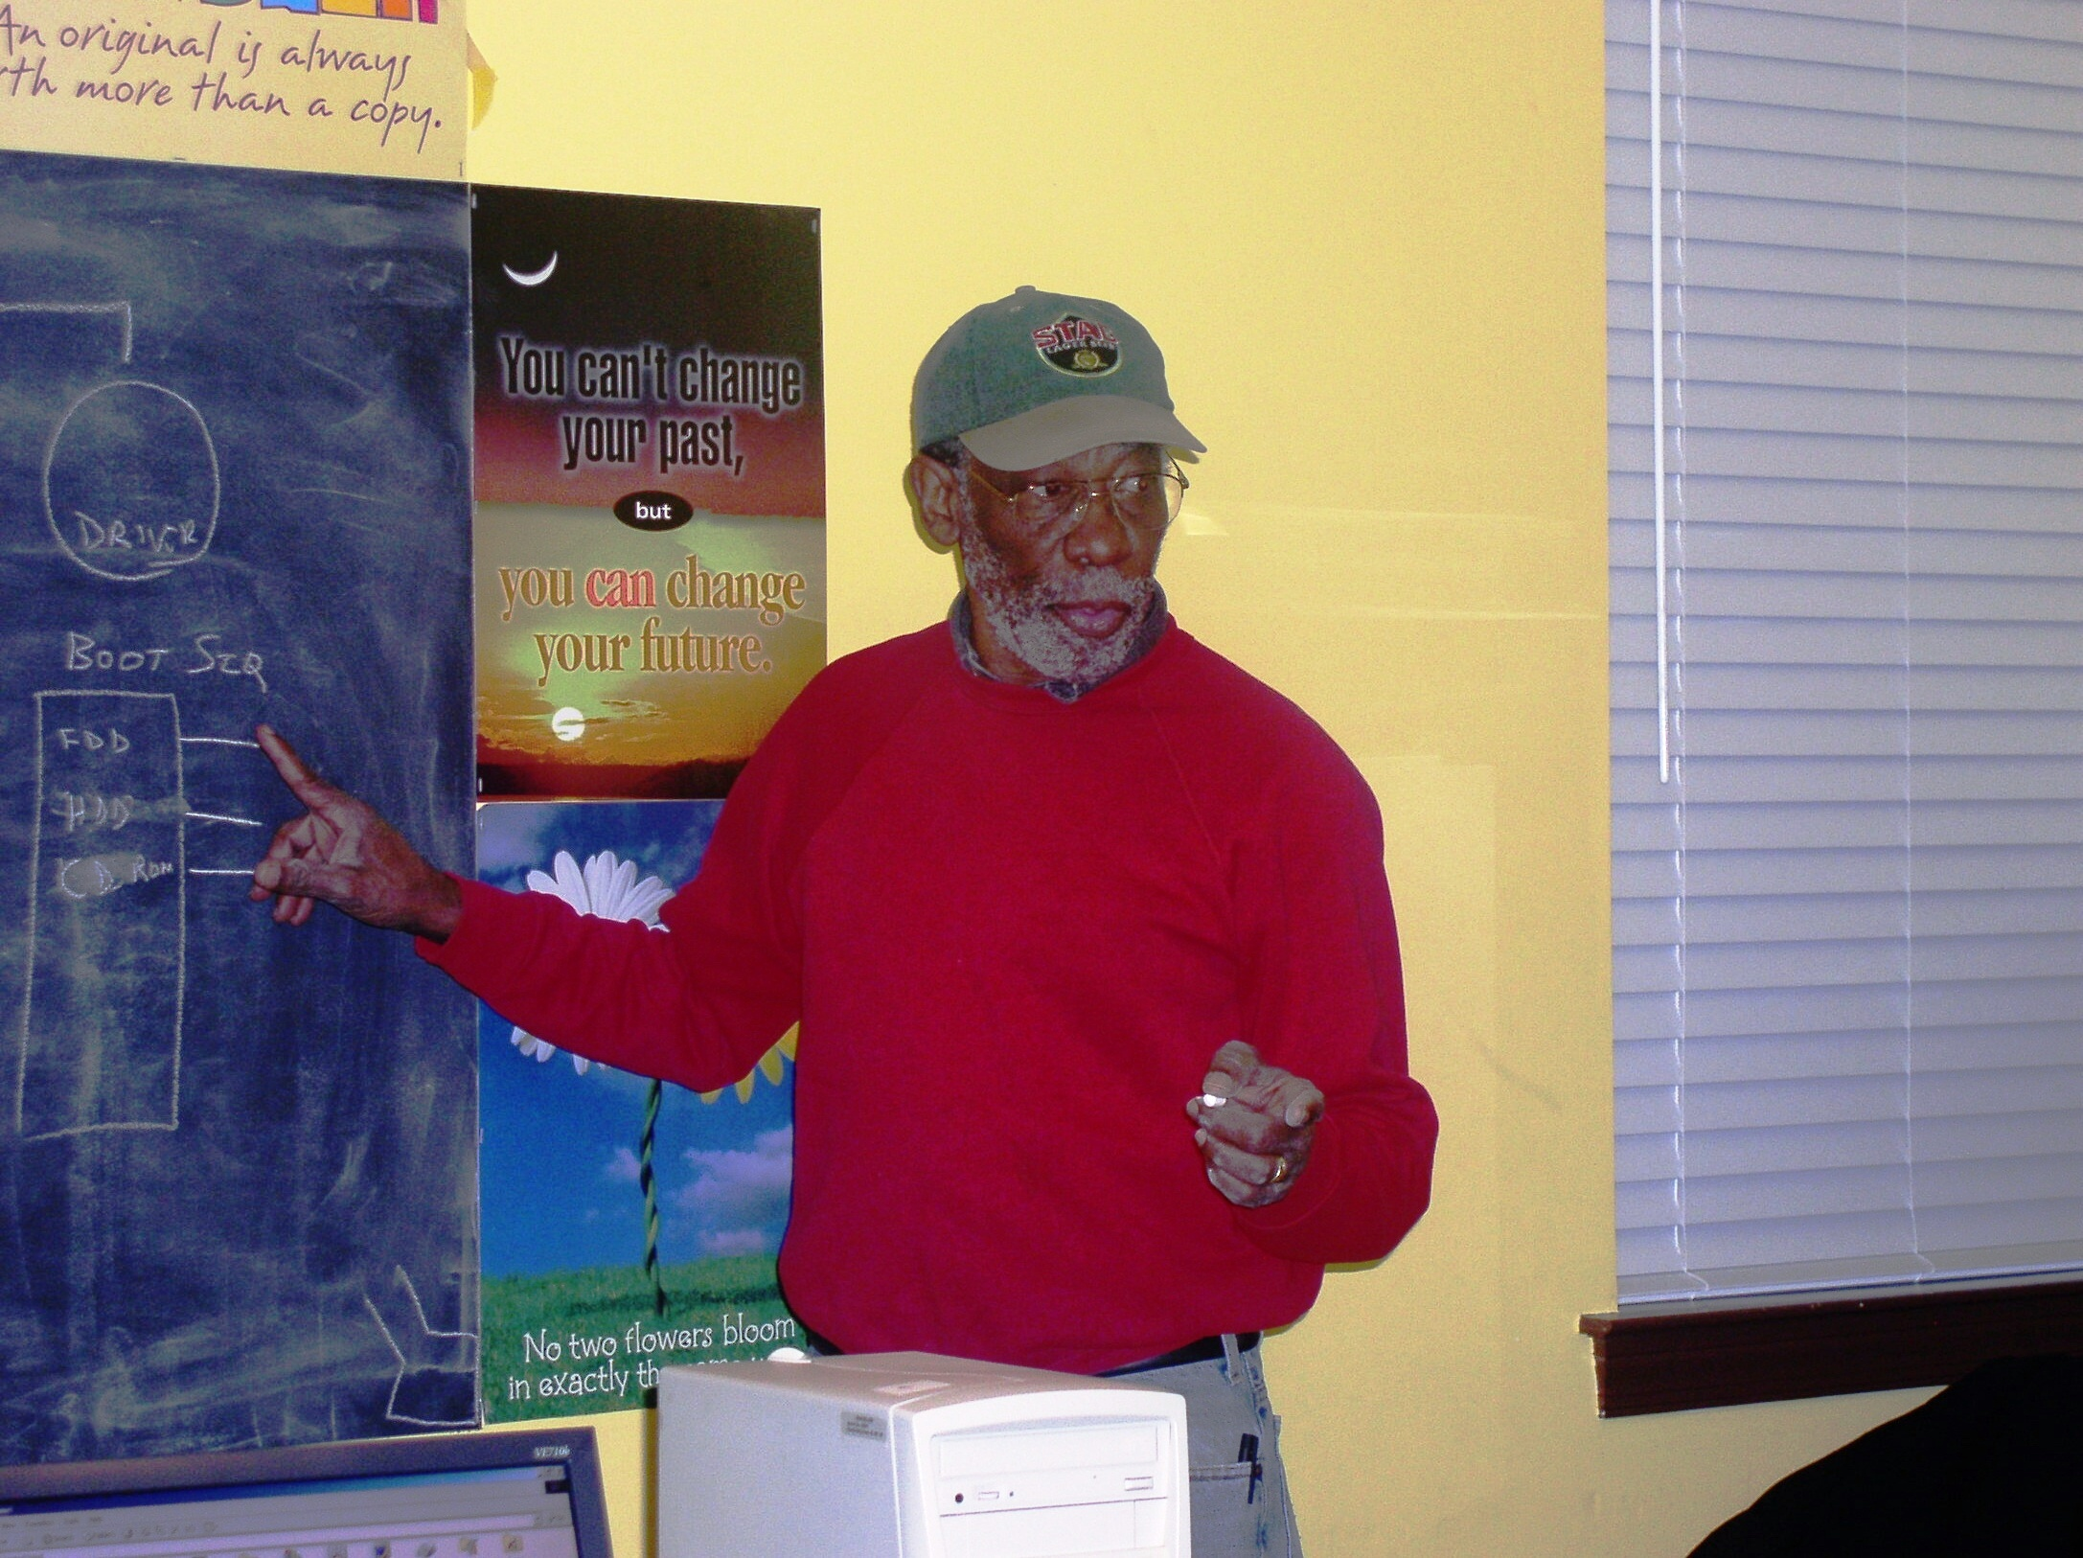
Neo Networks began a computer literacy program on Tuesdays and Thursdays, with hour-long classes starting at 5:30. Classes began September 14, 2006, and are conducted by Earle Frederick.
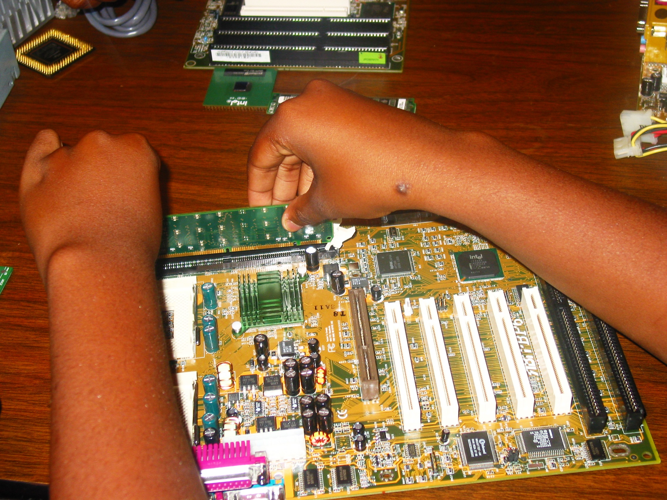
The classes are interactive, with individual student participation in the process of learning major computer components, arrangement and connections of the components, methods of installing an operating system and initiating networks.
(Graphs of the children’s program are available upon request.)

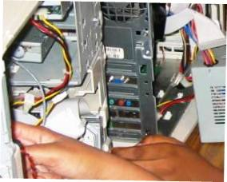

Typing classes are being taught by Stephanie Anderson. The computer-typing program keeps the scores of each child’s progress. This helps to improve the typing accuracy, speed and skills of each student.

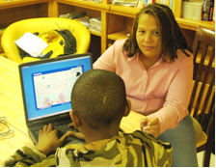


- The boys discuss with Jason Frederick and Justin Wingo about the "call to manhood," a special interactive program set up in an attempt to make sure the youngsters are oriented toward accepting their responsibilities as family leaders. Jason and Justin encouraged the boys to discuss their problems, including concerns they had not shared with adults. The mentoring was particularly aimed at boys in the fifth, sixth and seventh grades, encompassing a period of transition for the youths.

Neo With Students on Field Trips
Justin and Jason participated in the children’s outdoor activities and also accompanied them on a field trip to play in the park.
On November 14, 2006, Earle Frederick toured the Atlanta Detention Center with 20 youngsters and six staff members of the Reef House. The prison officers spoke about the activities within the facility.
The children and staff observed the booking of prisoners, the workings of the security system, and toured the dining facilities and exercise areas. Prisoners talked to the children about life within the walls.
Youngsters observed several aspects of the detention center that emphasized these points:
- Avoiding incarceration by doing the right things, that is listening to their parents and choosing the right friends.
- The age of prisoners when they started getting involved in crime. What are their chances of getting out of prison?
- The loud sound of locking doors alone was forbidding and was frightening to many.

AT JOB CORPS CENTER
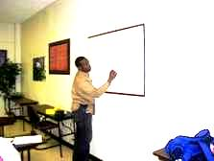
Consulted with director of counseling at Job Corps, who arranged for Neo Networks to meet with 20 students every Wednesday evening for a two-hour session.
An overall goal is to improve competence in mathematics, with the aim of scoring 600 on their TABE Tests. The target is to have at least 95 percent of students achieving scores of 600 within a short time period.
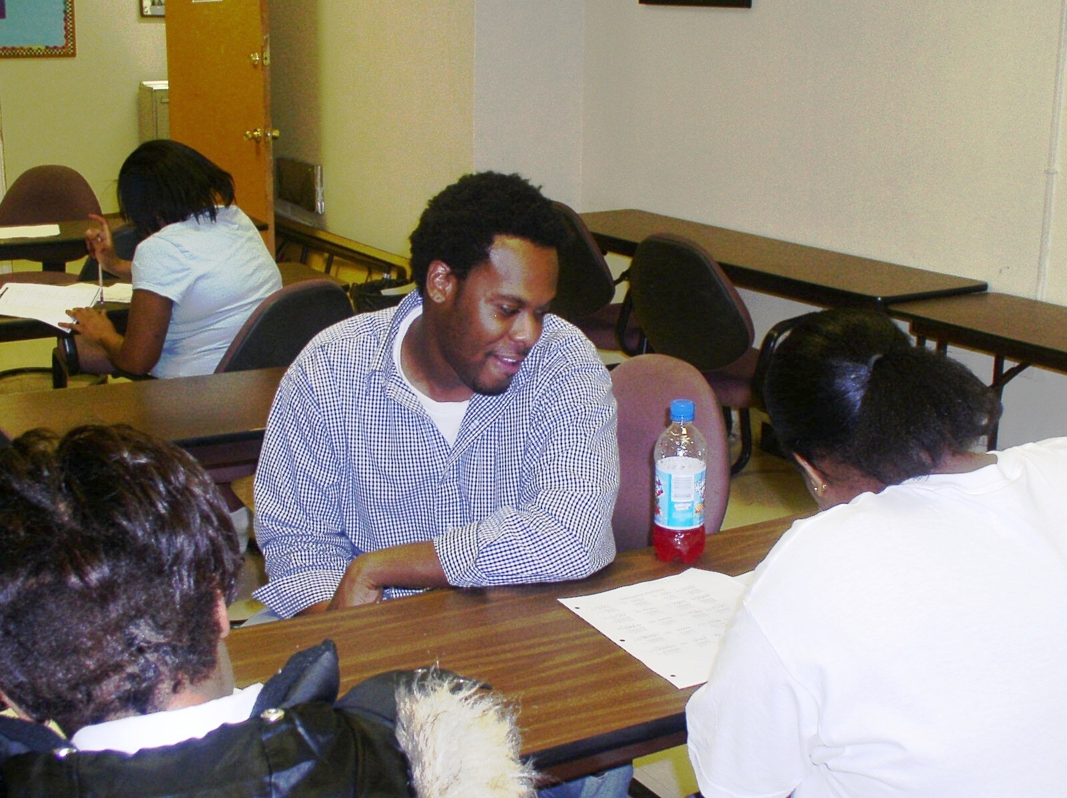
Jason Frederick, Justin Wingo, Marcel Johnson and Stephanie Anderson developed a method to assess the individual needs of the students. The students are then divided into groups, according to their needs and given the direct attention they need.

Neo Networks is consulting with Job Corps about starting additional tutoring classes in reading comprehension, resume writing, job searching techniques, job interviewing, and appropriate job etiquette.

TO THE SENIORS

Earle Frederick is helping selected seniors learn computers in their homes. The seniors love the one on one individual tutoring instead of the classroom setting.
In October 2006, the seniors knew little about the machines, how to navigate or how to use a mouse.
They learned how to use the machines, and were introduced to computer software, including games (Solitaire and FreeCell) that are helpful in increasing computer competence.
By December 2006, they were able to boast that they could communicate with their grandchildren by E-mail for Christmas, making them participants in the new age of digital communication.

MESSAGE FROM THE PRESIDENT

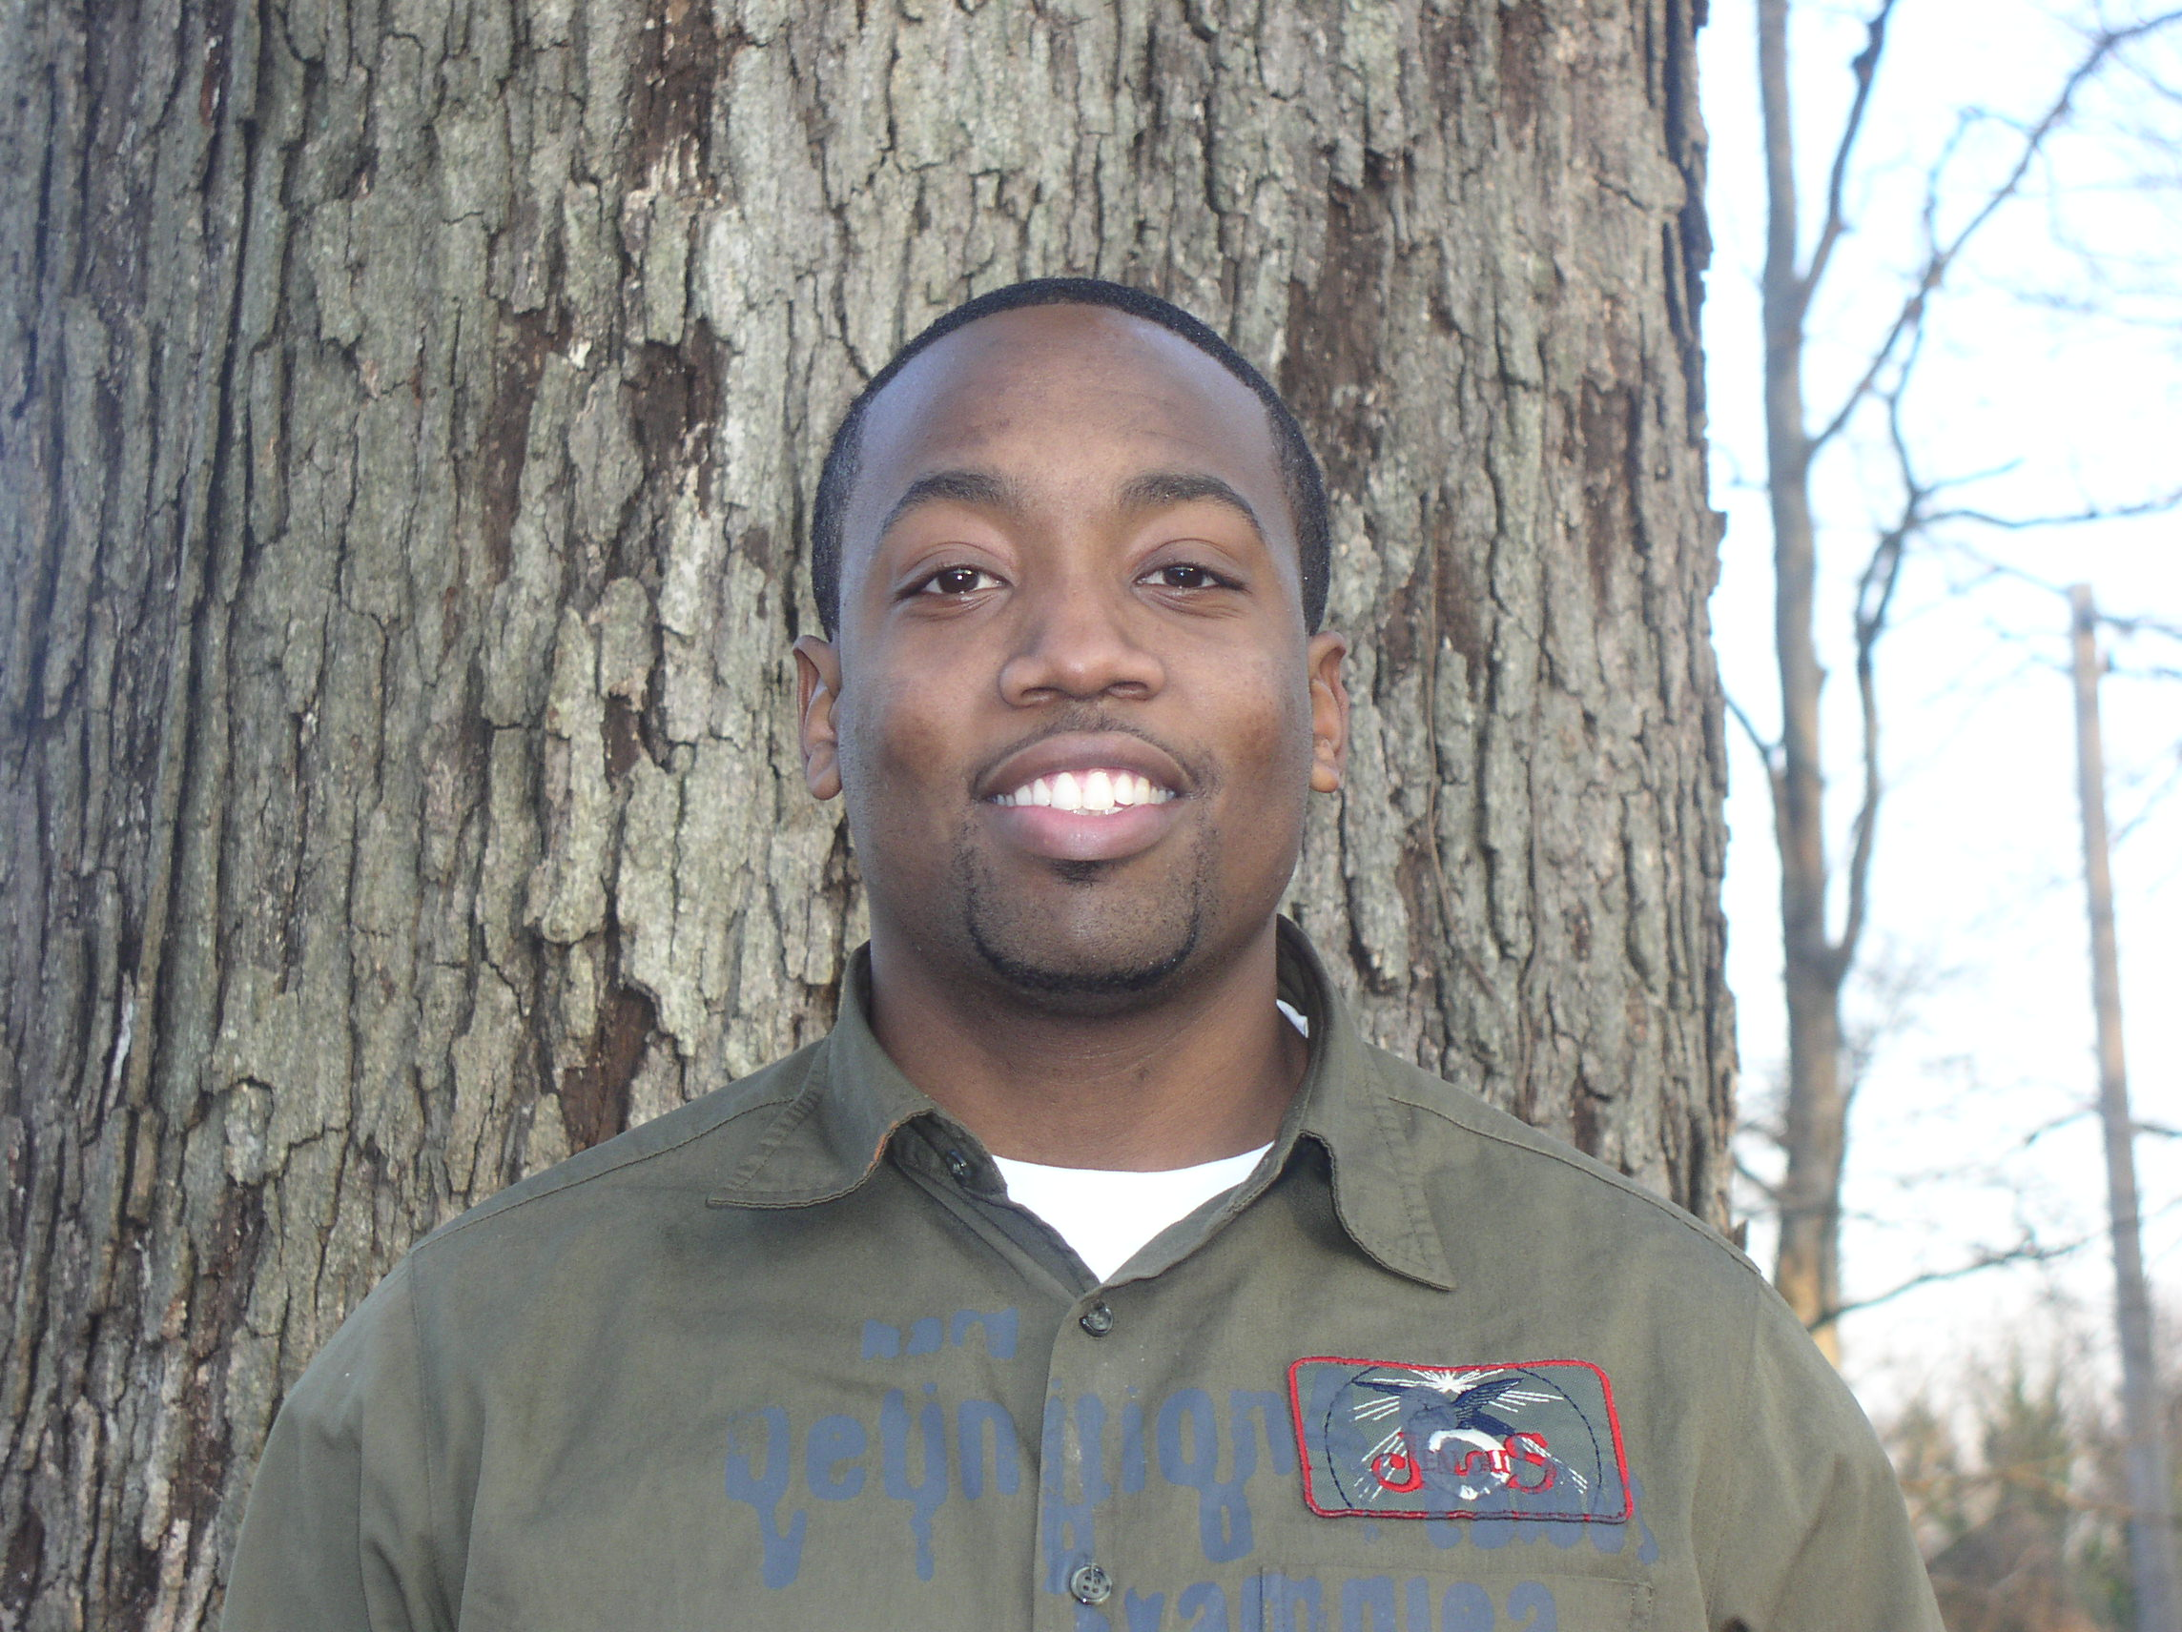
On behalf of the staff and board members I would like to extend thanks to all of the contributors and volunteers during 2006.
Because of your support Neo Networks was able to purchase four computers, which we plan to present to four deserving students who have no computer access at home. The computers will be presented to the students who show interest and who demonstrate the best overall performance in the classes.

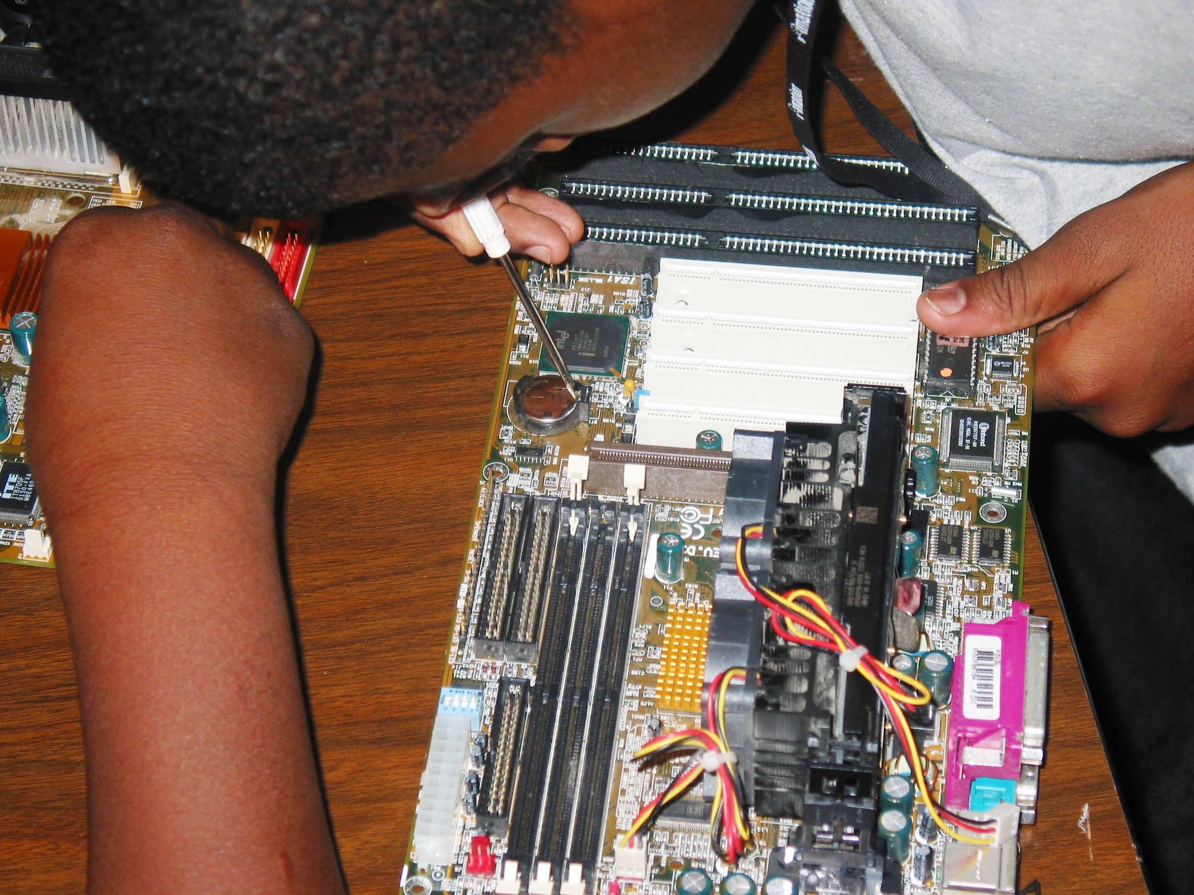

SPECIAL THANKS
To Ms. Quaadirah Abdur-Rahim, executive director, and her entire staff of the Reef House for providing us with the opportunity to teach the children.
To Mark Wadley, manager of career counseling and Charlene Bowens, career counselor at Job Corps for allowing Neo Networks to work with the youths.
As we move forward in 2007, we acknowledge that our success will depend on the continued support of our friends, donors, well-wishers and all our volunteers. Please spread the word about our aims and successes, and the demonstrated interest of the students in our community.
Please be ready to respond, as we call on all of those whose talents and skills may be of service to the less fortunate in our society.
Jason Frederick, CEO

HOW TO CONTRIBUTE

Neo Networks can always use help in various areas. If you would like to volunteer, donate, or make a monthly pledge, please send an email to neonetworks@comcast.net with your contact information and area in which you are able to help.

WISH LIST . . .

- Textbooks and practice workbooks on math and reading

- Insightful books to promote reading to students

- Additional licenses and software for typing

- Working and non-working computers, laptops, and printers

- Software licenses for laptops and computers

- Dreamweaver, Adobe Illustrator, Photoshop, Go Live, or Aftereffects software and licenses

- Documentation or books on learning how to use any web designing tools

- Funding to send students to specific summer training classes at local colleges

- Books and funding for A++ certification for computer hardware

