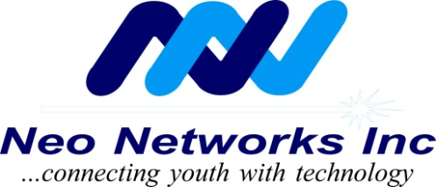

August 2013
Volume 1, Issue 7

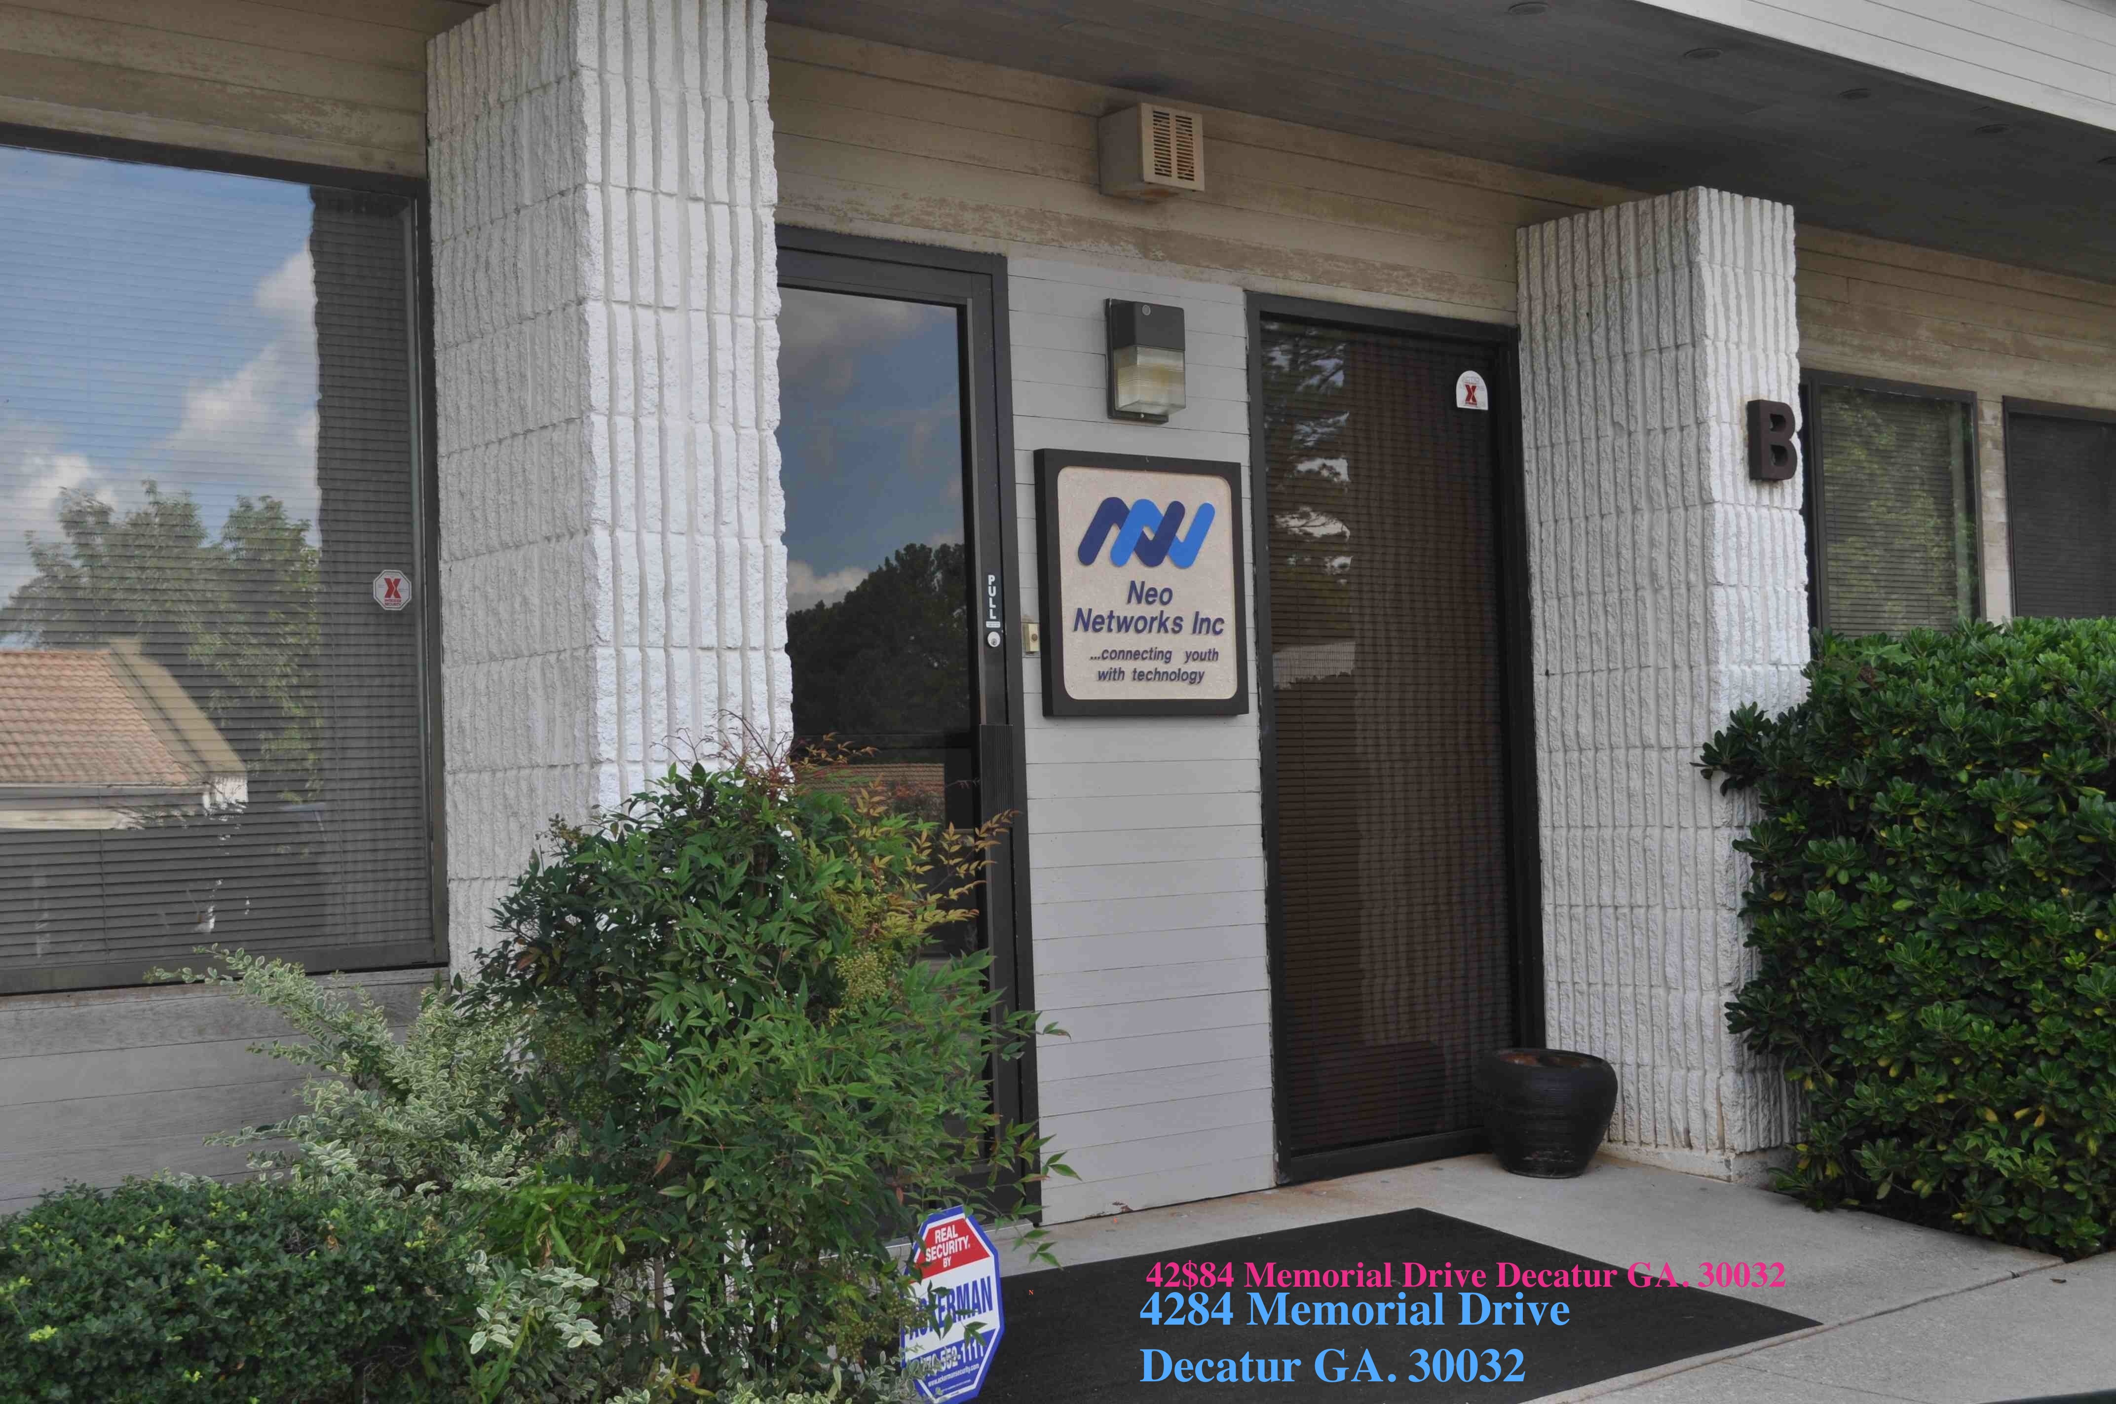

Neo Networks Office

Inside This Issue

- The President Speaks

- Special Thanks

- Accomplishments

- Neo Networks Future Plans.

- How to Contribute

- The Wish List

- Donor List

Neo Networks, Inc.
4284 Memorial Drive
Suite B
Decatur Ga. 30032
Ph. 404 -297-4678
neonetworks@comcast.net
www.neonetworksinc.org

A Not For Profit Organization

The President
THE NETWORK
CONNECTION
Speaks…

The year 2013 has provided us with a brand new future for Neo Networks. With the help of your generous contributions and dedicated volunteers we are well on our way to complete our mission. Neo Networks’ mission is to foster development, nurture the spirit, assists youth in area of education and computer literacy, while also stimulating the desire for lifelong learning, intellectual curiosity, and promoting individual self-esteem.
We specialize in working with students of all demographic backgrounds. Neo Networks has been involved in the community for the last seven years and we focus the majority of our resources in DeKalb County. We are located at 4284 Memorial Drive, Suite B, Decatur Ga. 30032 (appox. 5 minutes) walking distance from the Marta Kensington station.

Jason Frederick / CEO

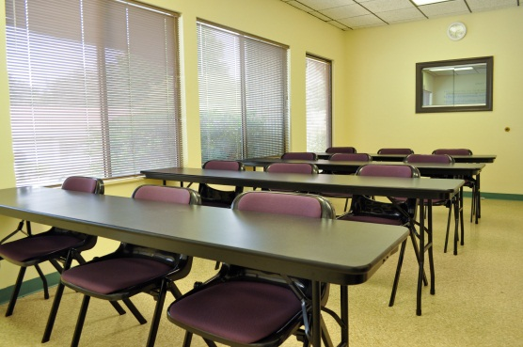

Picture of our tutoring center

Question:
- How was the name Neo Networks created?

Jason:
Neo Networks is based on the movie titled “The Matrix”. In the matrix, the fictional character Neo, learns that his life as he knows it has been a total illusion. Initially, Neo has a difficult time accepting his newly discovered concept on life, but he is then liberated by his peers to face his fate as a leader. As soon as Neo embraces his role as a leader and understands who he is. At that moment he is able to transcend and apply his knowledge in the new world that he has now adopted and he instantly becomes furious, with a dangerous impact.
When I decided to change my career from a computer programmer to a Math teacher, I discovered my true fate just like Neo of the matrix. I embraced my desire to help and nurture students by creating a non-profit organization. As with many things in life, I had to come up with a name and the first character or name that came to my mind was Neo because after he was able to apply his knowledge to unimaginable problems, he had then conquered this new world. Hence, the name “Neo Networks” where I want to offer my knowledge of education and network my knowledge to other people so that they can apply their newly learned concepts to their own unimaginable circumstances, just like Neo in the matrix.

Question:
(2) When was Neo Network established and who has the company worked with?

Jason:
Neo Networks was established in January 2006. In the last seven years, we have worked with several after school programs in the metropolitan area (Job Corps, DeKalb Workforce, Senior Centers, and etc.) which included a multicultural group of diverse students from the inner city to Africa to refugees. We also created mentoring groups, provided homework help, taught computer literacy, and provided food and nutrition classes. Last summer we provided scholarships to several students to go to Georgia Tech and Clayton State University. We also have an ongoing soccer team that we sponsor in Fulton County.

Question:
(3) What does Neo Networks provide?

Jason:
Neo Networks is a 501 (C) 3 non-profit organization that provides a service to students of all demographic categories that gives them the opportunity to improve their knowledge in several subjects. No matter what the level of a person’s financial status, a student still has the opportunity to gain the needed guidance to excel in their desired subject.

Question:
4) What type of classes does Neo Networks offer?
Jason: Currently we are focusing on high school classes and test preparation for high schools students. The classes are CCGPS Algebra for 9th grade students, Analytical Geometry for 10th grade students, Math 3 for 11 grade students, Math 4 for 12 grade students, SAT prep, ACT prep, and ASVAB prep. In the follow year we plan to revisit particular areas that need more attention and provide a flexible schedule to accommodate the needs of our students.

Question:
(5) Can you tell me a little about yourself?

Jason:
I am a high school math teacher for Fulton County (certified for 6-12) and I currently teach mathematics on a college level (Masters Degree in secondary math education). We provide all resources, which include a pre-test, mid-test knowledge assessment, and a final post-test to measure our students’ progress. In order to be effective, we require all students to meet twice a week.

Question:
(6) How big are the class sizes?

Jason:
The class sizes vary but the largest class size will be 12. We designed the classes to always consist of a small group. The classes are conducted on a first come first serve bases.

Question:
(7)) When are the classes held?

Jason:
Most classes are held on the weekend, which consist of Saturday and Sunday. Weekday classes are held on an as needed basis. Please check our calendar at the center or call a representative for the class schedule.

Question:
(8) Which schools are Neo Network currently focusing on?

Jason:
We are currently only focusing on high schools and colleges in DeKalb area. We are open to any other students who are interesting in being tutored within the metro area.

Question:
(9) Who is involved with Neo networks?

Jason:
Jason Frederick (CEO/COO), Justin Wingo (Vice President), and Stephanie Anderson (Secretary/ Department Assistant).

The Board of Members are: Ernest Holsendolph, Jim Williams, and Earle Frederick

Question:
(10) Has Neo networks received any recognition or awards for their work?

Jason:
Neo Networks was recognized by Bank of America and nominated to attend a Neighborhood Excellence Initiative seminar in California for emerging leaders. Neo Networks was also nominated and recognized by Job Corps of the USA as Important Community Leaders for Job Corps in Atlanta. Lastly Neo Networks, was nominated by Fulton County for our after school program and services in Fulton County.
Jason Frederick
CEO / Neo Networks

SPECIAL THANKS

Thanks to Mr. Kevin Wren of Executive Sherpa, LLC for providing the necessary tools for Neo Networks to fulfill our mission of changing the way in which youth learn through use of digital media tools and online solutions, such as our new Promethean Board.

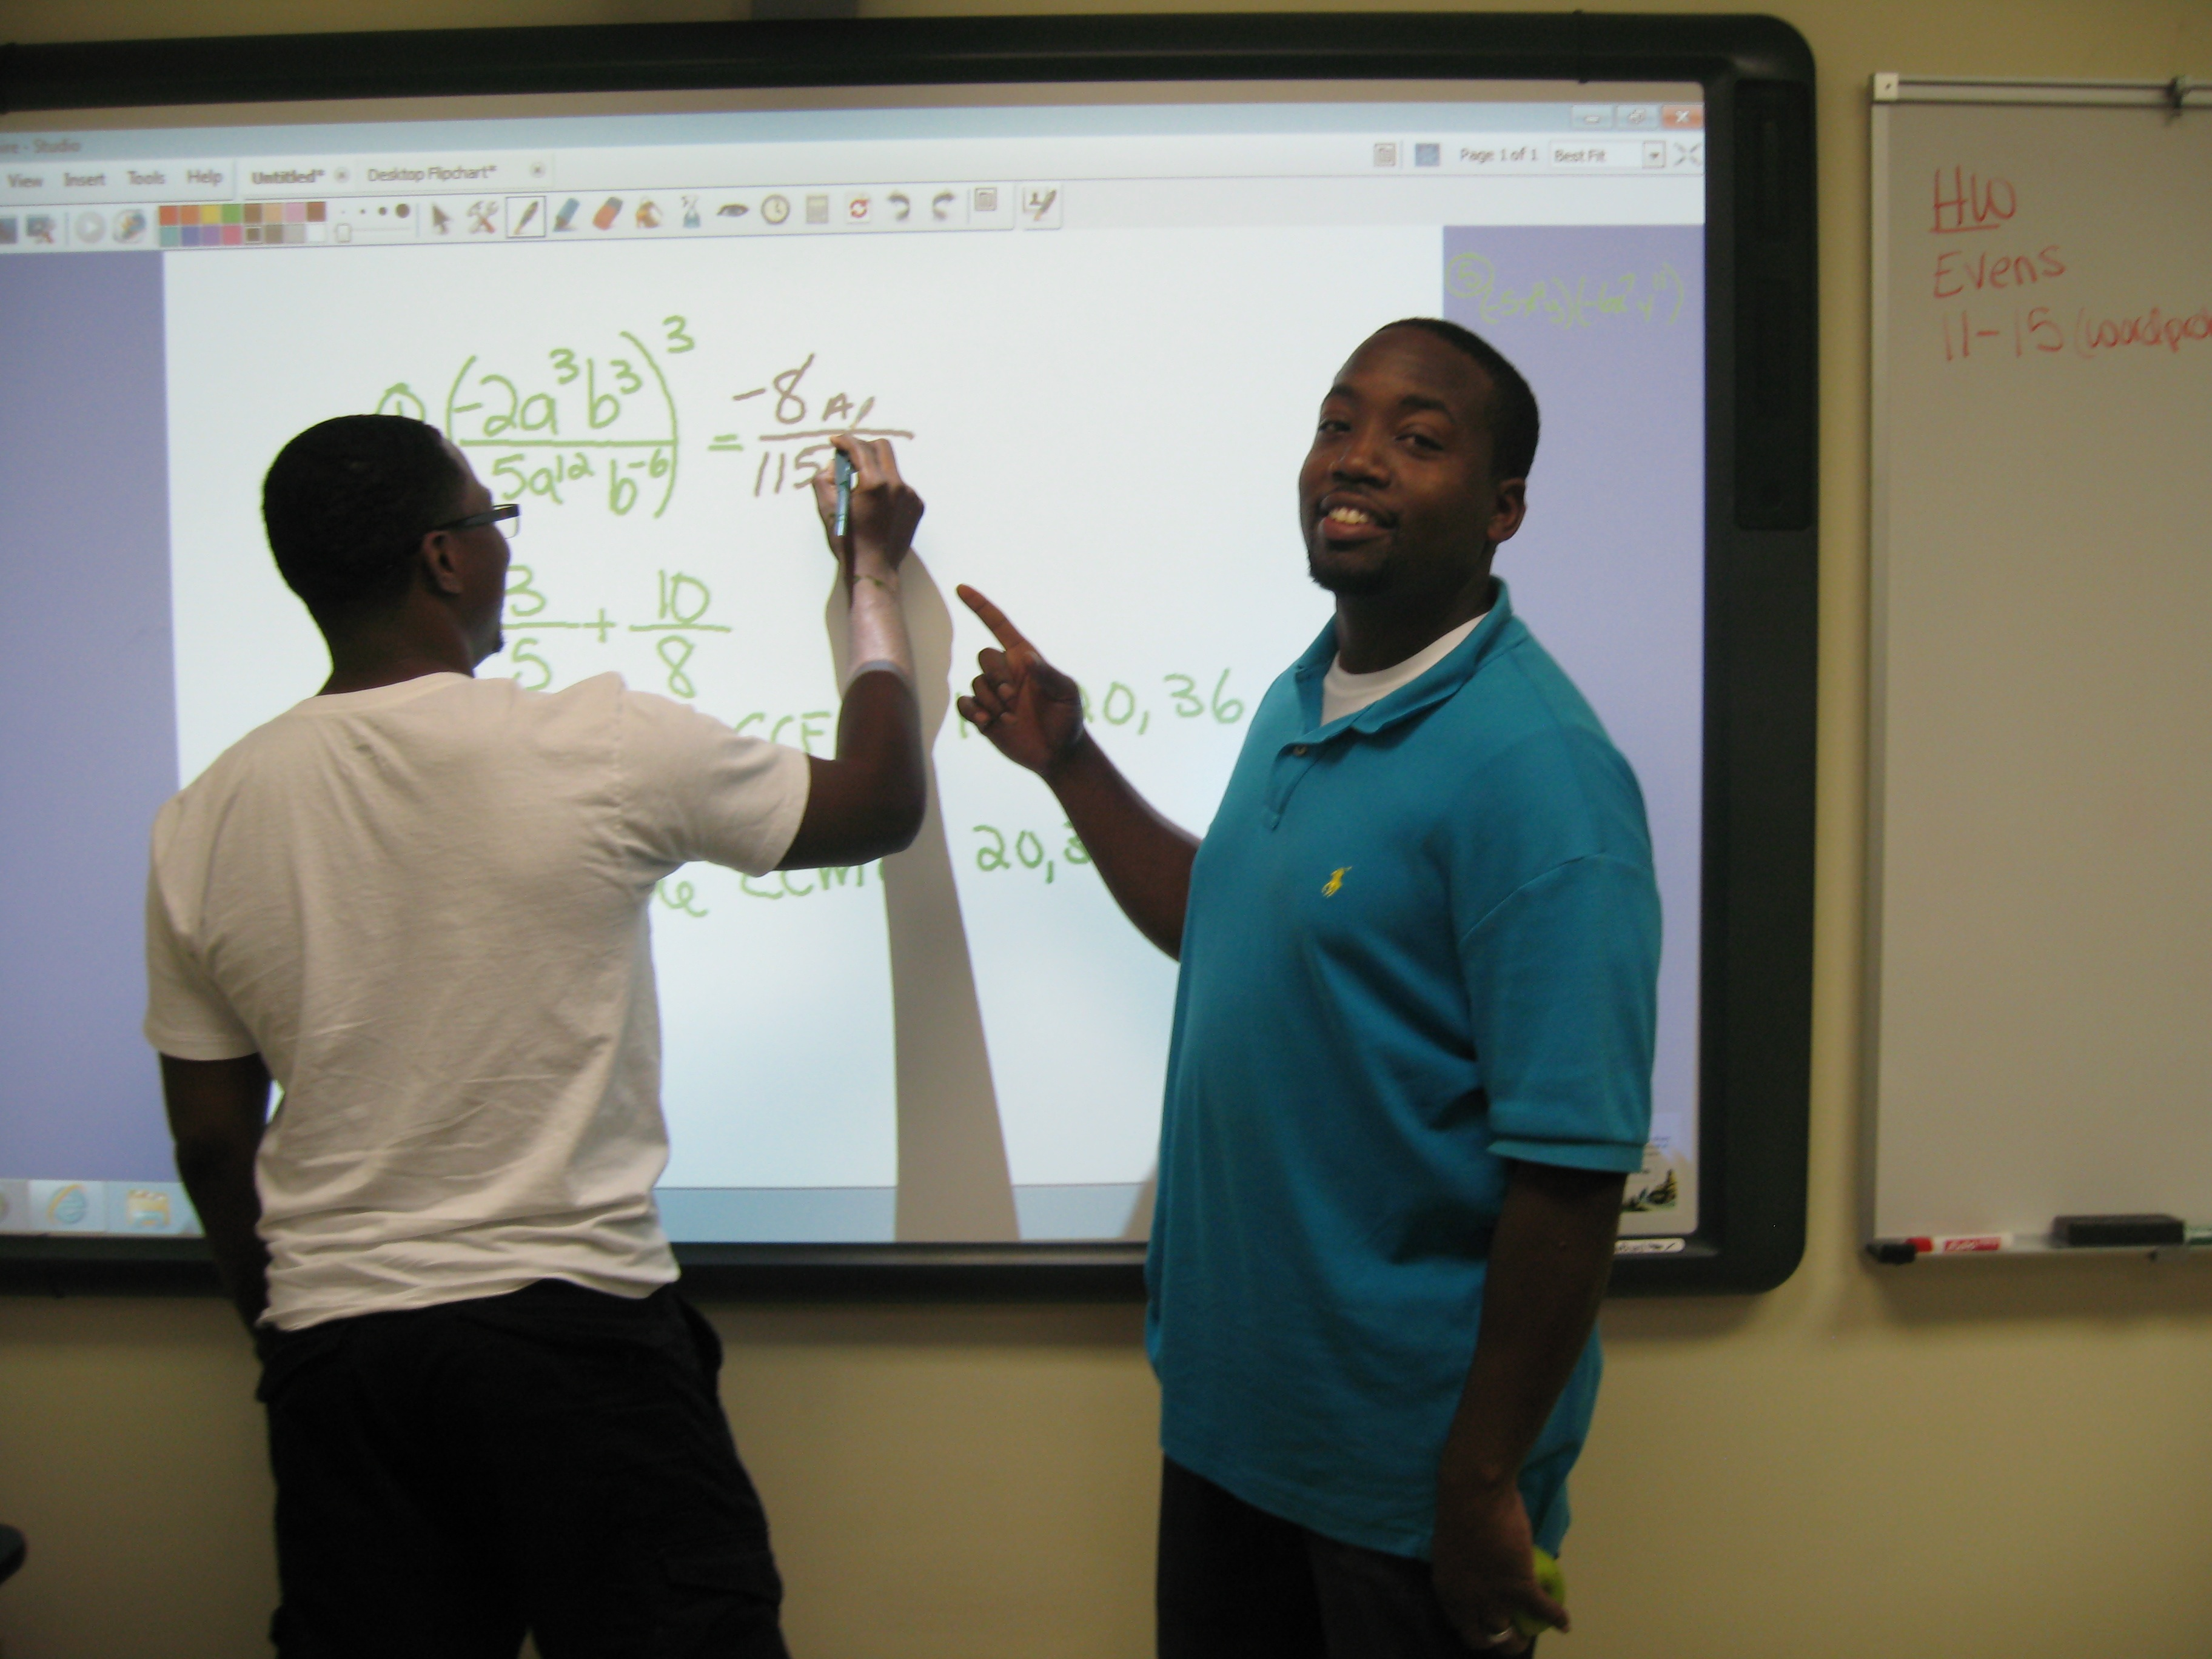
Jason shows a student how to solve math problems on the Promethean Board.
ACCOMPLISHMENTS:

It has been over seven years since I began my dream of having Neo Networks mentoring and teaching technology skills to youth and adults of all ages and nationalities. To date, I am very proud of our accomplishments and I look forward to establishing relationships with additional organizations, as well as extending our efforts to other neighboring cities.

This year Neo Networks received several awards for our work in the Community.

(1) Neo Networks continues to teach computer literacy at Senior Community Centers in DeKalb County.

2) Neo Networks participates in after school programs at the Recreation Center. Neo Networks helps the students in kindergarten and fifth grade with the following:

(a) Homework assignments and special projects.

(b) Provides school supplies, on an as needed basis.

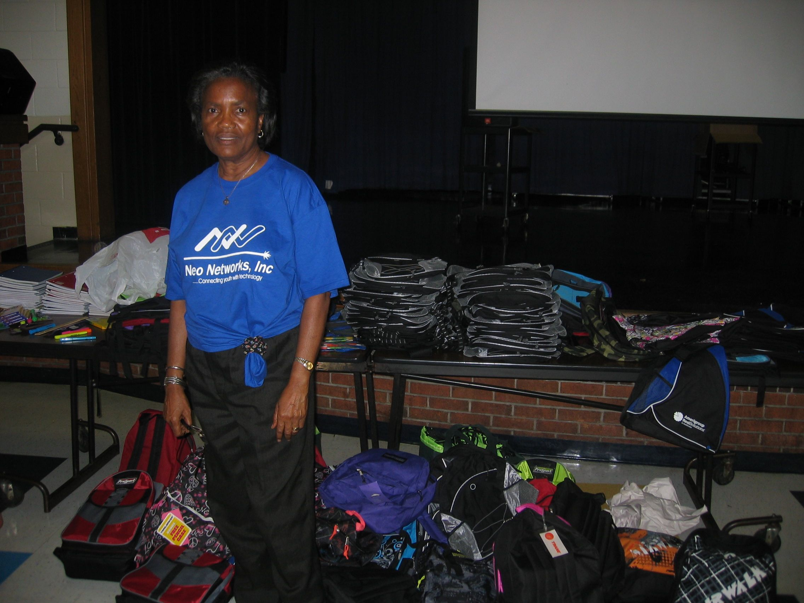
Neo Networks Donated School Supplies

(c) Opal Frederick, a registered nurse, continues to teach the students the importance of eating healthy foods and hand washing.

(d) Earle Frederick provides Line Dance Music, Reggae Music and Soca Music for birthday parties at special functions held at a Senior Center.

(3) During the Christmas holidays, Neo Networks participated in feeding the homeless at a local church in Atlanta

(4 )Neo Networks sponsored the Christmas Holiday Party at the Recreation Center After School Program.

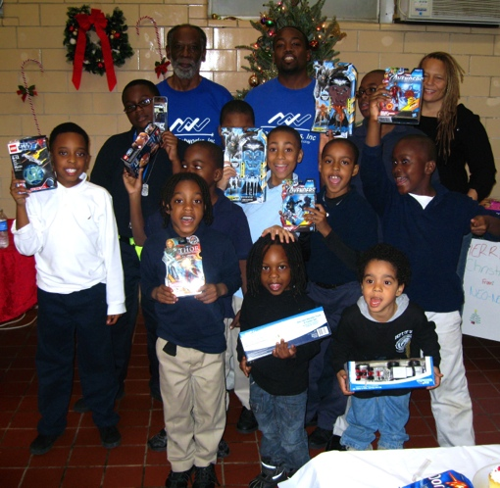
Earle, Jason and Stephanie with Students

CERTIFICATE OF APPRECIATION

DeKalb County Youth Group thanked Neo Networks for sponsoring and participating with Partnership For Community Action (DNLI Youth Group) to clean up Austin Oaks apartment complex.

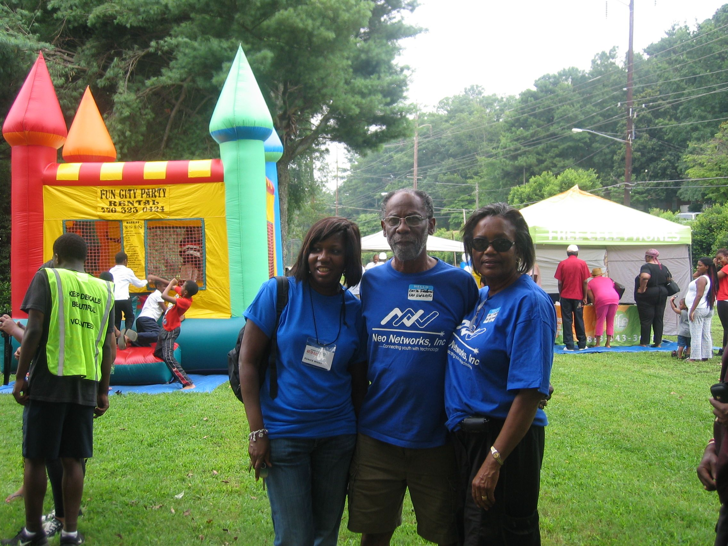

. Neo Networks At Austin Oaks
Clean Up Volunteers
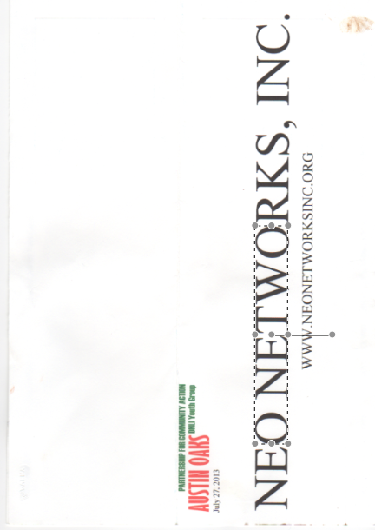
Flier

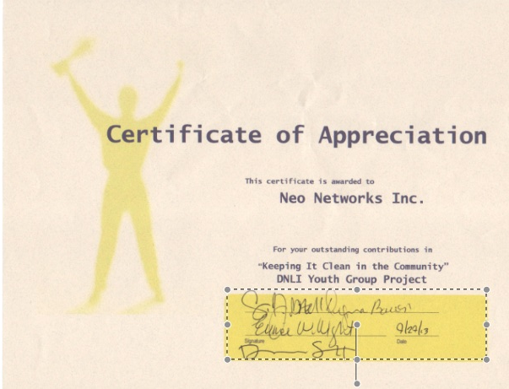
. Certificate

SENIOR CENTER
VOLUNTEER
AWARDS:

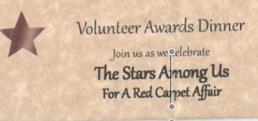

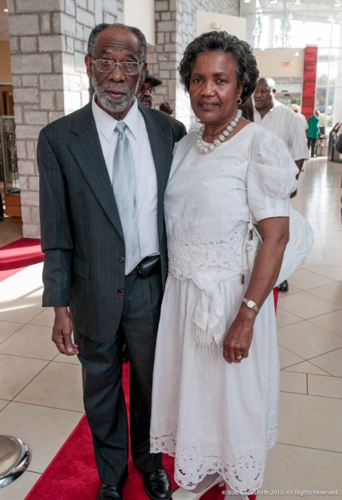

Earle and Opal at the Red Carpet Affair

NEO NETWORKS FUTURE PLANS…

Continue to teach computer literacy at other community Centers.

Continue our after school programs and expand into other community centers if possible.

Assist with youth soccer programs.

HOW TO

CONTRIBUTE

Neo Networks can always use help in various areas. If you would like to volunteer, donate, or
make a monthly pledge, please send an email to neonetworks@comcast.net with your contact information and area in which you are able to help.

THE WISH LIST

1. Educational Programs and
Books

2. School supplies-Pencils and
Paper

3. Laptops or Small Desktop
Computers to build computer
Lab.

4. Electronic Project Kits for
students between the ages of

12 – 18 years old

DONOR’S LIST

Our success is the result of our dedicated supporters.

Neo Networks thanks you for your generous contributions.

FOUNDATION COMPANIES

The Billi Marcus Foundation Inc.
Carey Paul Honda
Executive Sherpa, LLC (Delaware)
Gripwire (Seattle, WA)
Kroger
Rose Partners LLC (Rochester, NY)
Target
Wal-mart

INDIDIVIDUAL DONOR’S LIST

Richard Leslie
Justin Wingo
Stephanie Anderson
Neil J. Cox
Rodney Taylor
Christine Peprah
Valrie McCray
Mr./Mrs . Shaka Hinds
Columbia Drive Baptist Church
Michael Bush
William A Parker JR
Carl Frederick
Earle Frederick
Jason Frederick
Opal Frederick
Robert Frederick
Jim Williams
Ernest Holsendolph
Bobby Sauer

